Chapter 8, Solution 65.

At the input of the first op amp,

(v_{o} – 0)/R = Cd(v₁ – 0) (1)

At the input of the second op amp,

(-v₁ – 0)/R = Cdv₂/dt (2)

Let us now examine our constraints. Since the input terminals are essentially at ground, then we have the following,

v_{o} = -v₂ or v₂ = -v_{o} (3)

Combining (1), (2), and (3), eliminating v₁ and v₂ we get,

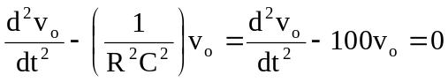

Which leads to s² – 100 = 0

Clearly this produces roots of –10 and +10.

And, we obtain,

v_{o}(t) = (Ae^{+10t} + Be^{-10t})V

At t = 0, v_{o}(0+) = – v₂(0+) = 0 = A + B, thus B = –A

This leads to v_{o}(t) = (Ae^{+10t} – Ae^{-10t})V. Now we can use v₁(0+) = 2V.

From (2), v₁ = –RCdv₂/dt = 0.1dv_{o}/dt = 0.1(10Ae^{+10t} + 10Ae^{-10t})

v₁(0+) = 2 = 0.1(20A) = 2A or A = 1

Thus, v_{o}(t) = (e^{+10t} – e^{-10t}) V

It should be noted that this circuit is unstable (clearly one of the poles lies in the right-half-plane).

